California APCO State Training Conference
APCO - The Association of Public-Safety Communications Officials - International

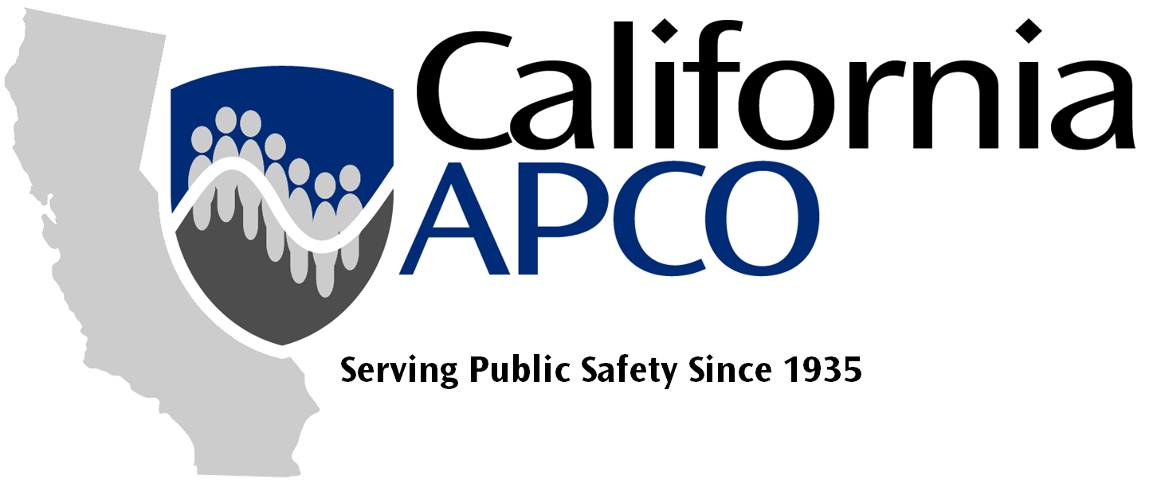

2026 Conference Chair

Terri Nelson
Phone: 714-425-1691
tnelcpra@gmail.com

2025 Conference Chair

TBA
Phone:
Email

Program Chair

Maria Esquetini

Phone:
Email

Program Co-Chair

TBA
Phone:
Email

Volunteer Chair

Casey Bostrom
Phone:
Email

Volunteer Co-Chair

TBA
Phone:
Email

Exhibits Chair

TBA
Phone:
Email

General Arrangements Chair

Pauline Soria
Phone:
Email

General Arrangements Co-Chair

TBA
Phone:
Email

Registration Chair

Ron Dunn
Phone:
Email

Registration Co-Chair

TBA
Phone:
Email

Finance Chair

John Wright
Phone:
Email

Finance Co-Chair

TBA
Phone:
Email

Security Chair

TBA
Phone:
Email

Security Co-Chair

Jeff Loveland
Phone:
Email

Publicity/Entertainment Chair

Tina Meyer
Phone:
Email

Publicity/Entertainment Co-Chair

TBA
Phone:
Email

Transportation Chair

Pending
Phone:
Email

Transportation Co-Chair

TBA
Phone:
Email

Webmaster / IT Chair

Liza Kester
Phone:
Email

CalAPCO Show Administrator

TBA
Phone:
Email
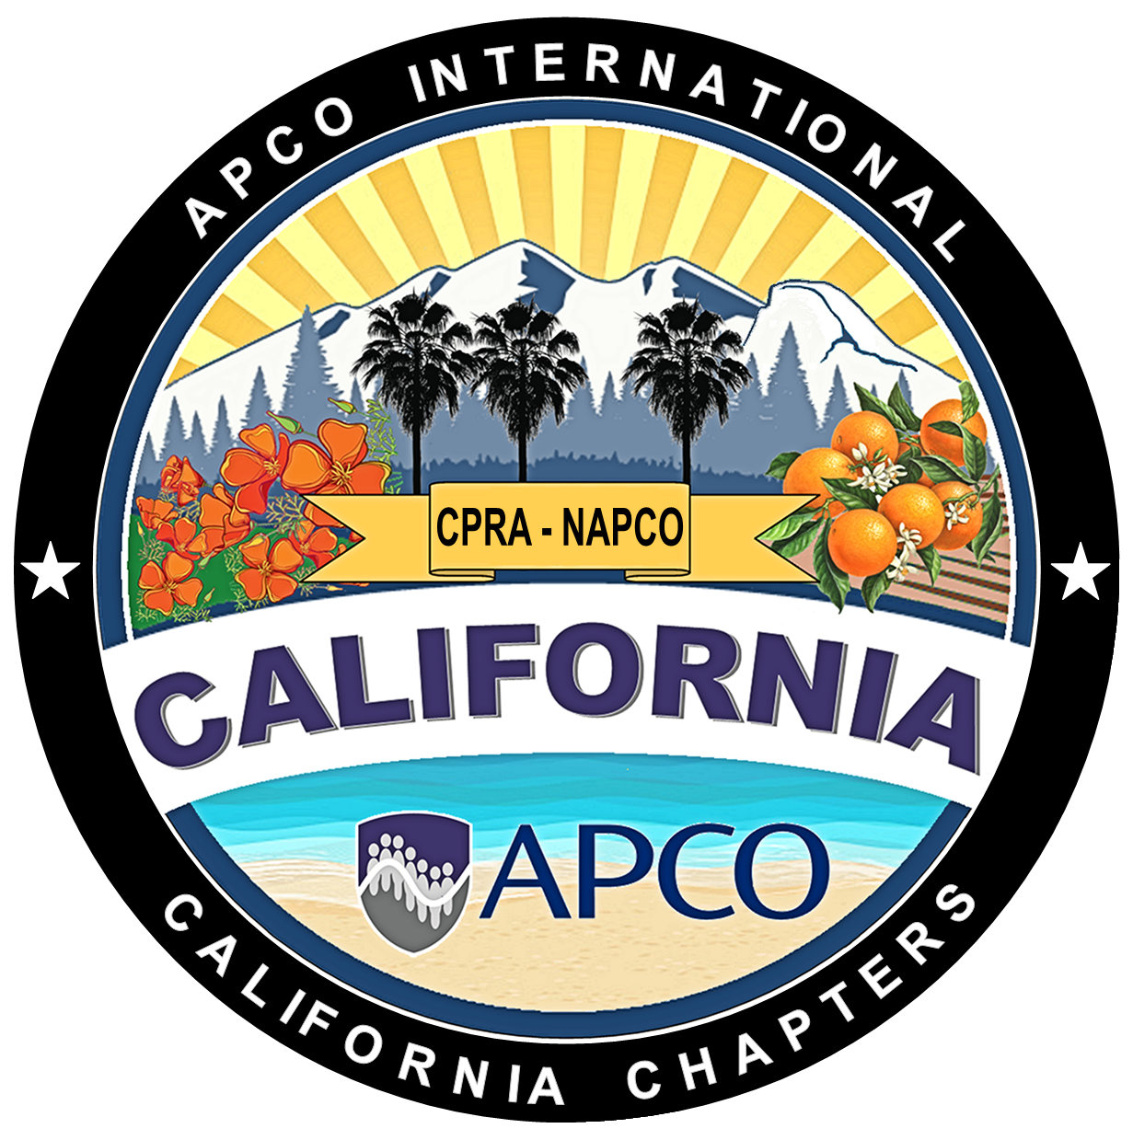
Southern California Northern California

California Public-Safety Radio Assoc. Northern California APCO
3410 La Sierra Ave., Suite F1185 6770 Stanford Ranch Rd #1158
Riverside, California 92503 Roseville, California 95678

Fax: 213-291-9411 Fax: 916-912-4451

The California Chapters of APCO International are 501(c)(3) nonprofit organizations
www.CalAPCO.org
Oct 7 – 9, 2026
Town & Country Convention Center
San Diego, CA

