California APCO State Training Conference
APCO - The Association of Public-Safety Communications Officials - International

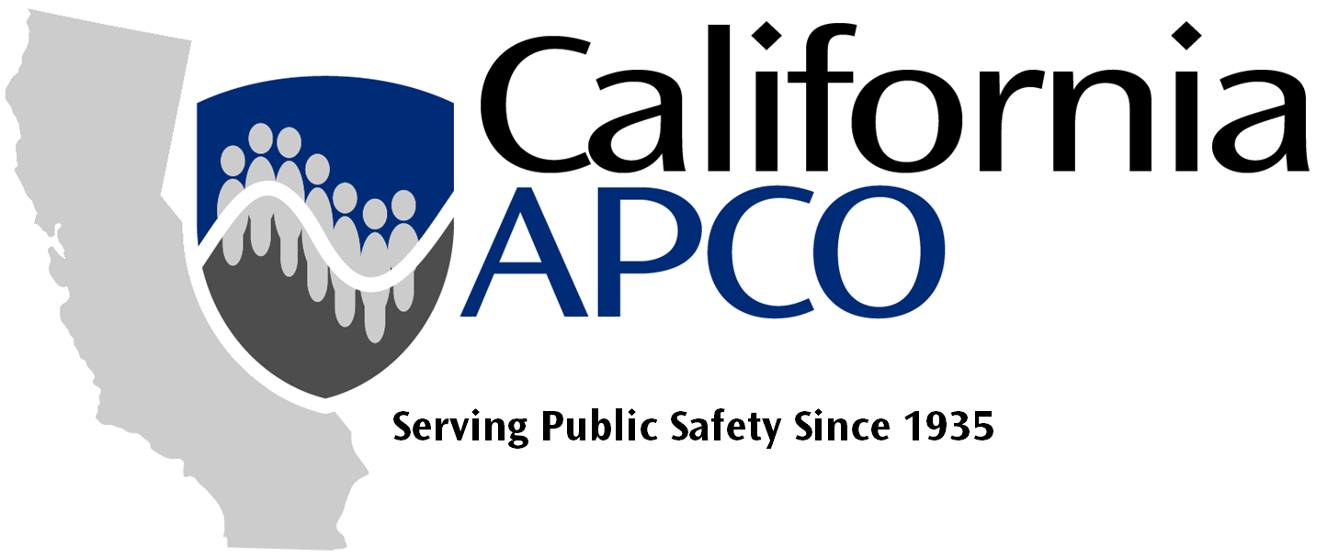
2025 Conference Chair

Manny Vierra
Phone: 408-309-3954
mannyvierra@hotmail.com

2025 Conference Chair

John W Wright
Phone: 951-905-2746
Rfanalyst@gmail.com

Program Chair

Tristan Skraber
Phone: 916-298-6385
Tristan.skraber@napco.org

Program Co-Chair

Pauline Soria
Phone: 949-824-5688
plsoria@uci.edu

Volunteer Chair

Susie Rivera
Phone: 916-956-0272
Susie.rivera222@gmail.com

Volunteer Co-Chair

Kevin R. Nida
Phone: 202-868-7670
Kevin.Nida@FirstNet.gov

Exhibits Chair

Manny Vierra
Phone: 408-309-3954
mannyvierra@hotmail.com

General Arrangements Chair

Karl Grover
Phone: 916-774-5145
kgrover@roseville.ca.us

General Arrangements Co-Chair

Maria Esquetini
Phone: 714-562-3930
mesquetini@bppd.com

Registration Chair

Jim Lencioni
Phone: 530-368-0241
JLencioni@placer.ca.gov

Registration Co-Chair

Terri Nelson
Phone: 714-425-1691
tnelcpra@gmail.com

Finance Chair

Jackie Andrews
Phone: 916-599-4028
Jackie.napco@gmail.com

Finance Co-Chair

John W Wright
Phone: 951-905-2746
Treasurer@cpra.org

Security Chair

Shawn Allan
Phone: 209-484-6761
Shawn.allan@stocktonca.gov

Security Co-Chair

Jeffrey Loveland
Phone: 951-897-3634
sergeantatarms@cpra.org

Publicity Chair

Shelly McMahon
Phone:
shelly.mcmahon@caloes.ca.gov

Entertainment Chair

Anna Trindade
Phone: 209-937-8620
anna.trindade@stocktonca.gov

Transportation Chair

Pending
Phone:
Email

Transportation Co-Chair

Ron Dunn
Phone: 951-201-0721
rdunn.cpra@gmail.com

Webmaster / IT Chair

Jim Lencioni
Phone: 530-368-0241
JLencion@placer.ca.gov

CalAPCO Show Administrator

Patti Peters
Phone:510-506-6060
peters.patti45@gmail.com
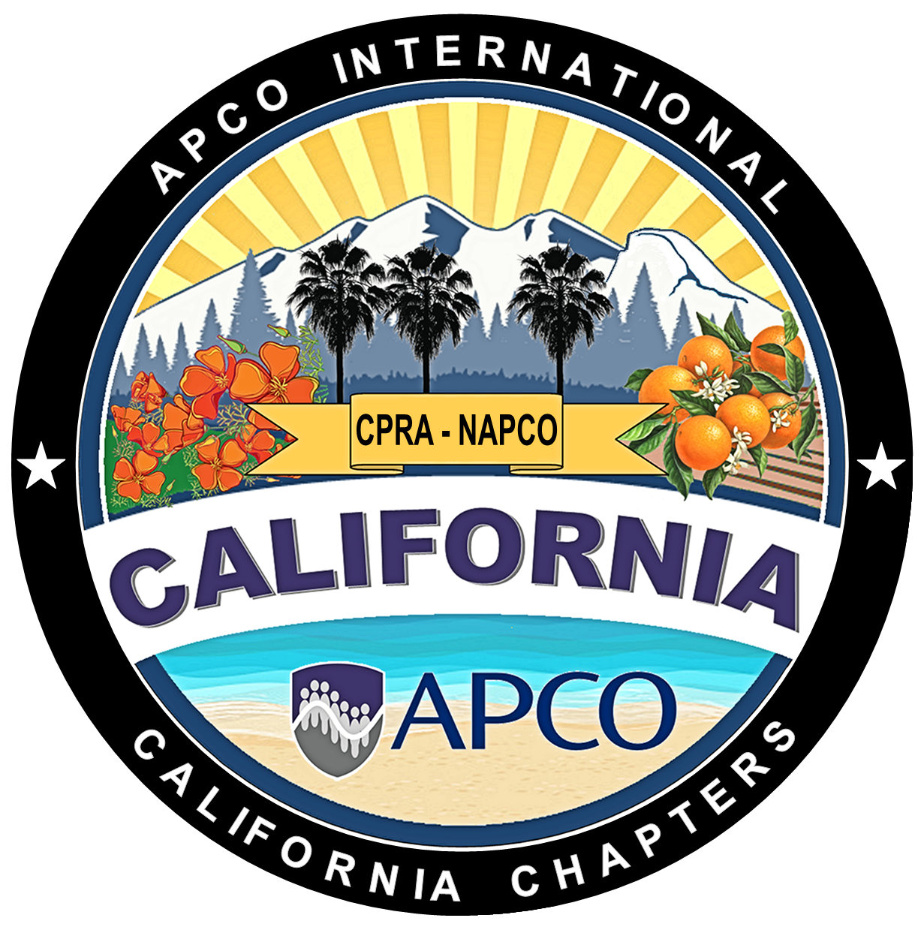
Southern California Northern California

California Public-Safety Radio Assoc. Northern California APCO
3410 La Sierra Ave., Suite F1185 6770 Stanford Ranch Rd #1158
Riverside, California 92503 Roseville, California 95678

Fax: 213-291-9411 Fax: 916-912-4451

The California Chapters of APCO International are 501(c)(3) nonprofit organizations
www.CalAPCO.org

Sept 30 – Oct 2, 2025
SAFE Credit Union Convention Center
Sacramento, California

